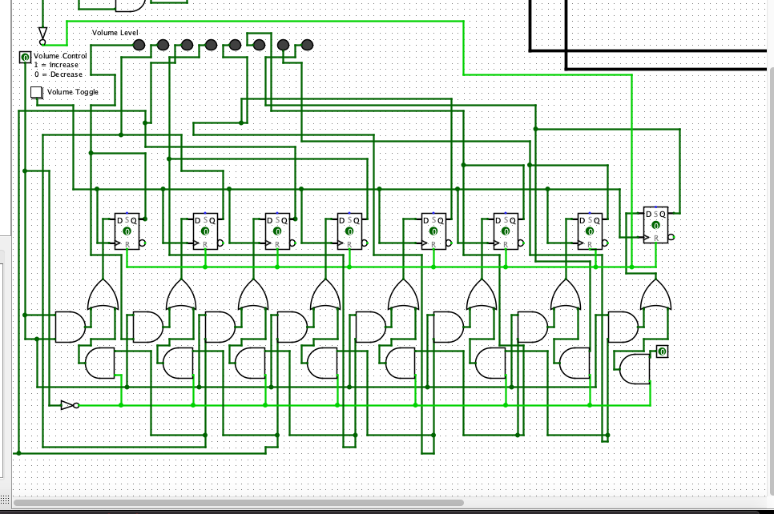

**For this week I tried building the music volume control**